

CIS C290

M05 Lab Assignment: Supervised Learning

Part 1. Load the go_surfing.csv file into the Python environment and run a logistic regression with an 80/20 split for training and testing and model evaluation. Include a screenshot of the results
#Load the data from go_surfing.csv. Load the data from the specified CSV file into a pandas DataFrame
import pandas as pd
df = pd.read_csv('/content/go_surfing.csv')

# Display the first few rows of the DataFrame to confirm the data is loaded
print(df.head())

# Logistic regression with the target variable is 'go_surfing' and the predictor variables are weekend, small_waves, popular_location, good_weather, summer, morning_time, wetsuit_needed, close_drive.

import pandas as pd
from sklearn.model_selection import train_test_split
from sklearn.linear_model import LogisticRegression
from sklearn.metrics import classification_report, confusion_matrix
import statsmodels.api as sm
import matplotlib.pyplot as plt
import seaborn as sns

# Define predictor and target variables
X = df[['weekend', 'small_waves', 'popular_location', 'good_weather', 'summer', 'morning_time', 'wetsuit_needed', 'close_drive']]
y = df['go_surfing']

# Split data into training and testing sets
X_train, X_test, y_train, y_test = train_test_split(X, y, test_size=0.2, random_state=42)

# Fit logistic regression model using statsmodels for summary table
X_train_sm = sm.add_constant(X_train) # Adding a constant for the intercept
model = sm.Logit(y_train, X_train_sm).fit()
print(model.summary())

# Fit logistic regression model using scikit-learn for predictions
clf = LogisticRegression(random_state=42).fit(X_train, y_train)
y_pred = clf.predict(X_test)

# Evaluate the model
print(classification_report(y_test, y_pred))

# Confusion matrix
cm = confusion_matrix(y_test, y_pred)
plt.figure(figsize=(8, 6))
sns.heatmap(cm, annot=True, fmt="d", cmap="Blues",
xticklabels=['Not Surfing', 'Surfing'],
yticklabels=['Not Surfing', 'Surfing'])
plt.xlabel("Predicted")
plt.ylabel("Actual")
plt.title("Confusion Matrix")
plt.show()

# Most predictive variables (based on coefficients)
coefficients = pd.DataFrame({'Variable': X_train.columns, 'Coefficient': clf.coef_[0]})
coefficients = coefficients.sort_values(by='Coefficient', key=abs, ascending=False)
print("\nMost Predictive Variables:")
coefficients

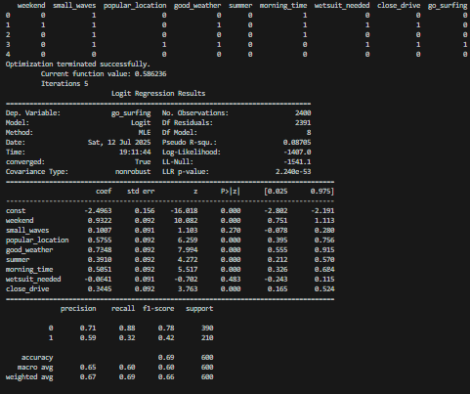
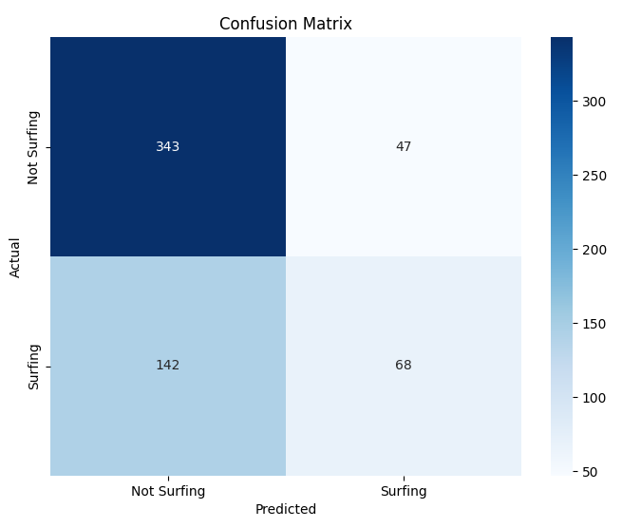

Part 2. Load the go_surfing.csv file into the Python environment and run a classification decision tree an 80/20 split for training and testing, including model evaluation, and 3-level tree. Include a screenshot of the results
# Classification decision tree. The target variable is 'go_surfing' and the predictor variables are weekend, small_waves, popular_location, good_weather, summer, morning_time, wetsuit_needed, close_drive. Create a summary table of the decision tree output. Include a graph of the tree at 3 levels. Create a table of the evaluation with precision, recall, and f1 scores. Indicate the most predictive variables.

import pandas as pd
from sklearn.model_selection import train_test_split
from sklearn.tree import DecisionTreeClassifier
from sklearn.metrics import classification_report, confusion_matrix, precision_score, recall_score, f1_score
from sklearn import tree
import matplotlib.pyplot as plt

# Assuming df is already loaded from the previous code block

# Define predictor and target variables
X = df[['weekend', 'small_waves', 'popular_location', 'good_weather', 'summer', 'morning_time', 'wetsuit_needed', 'close_drive']]
y = df['go_surfing']

# Split data into training and testing sets
X_train, X_test, y_train, y_test = train_test_split(X, y, test_size=0.2, random_state=42)

# Initialize and train the decision tree classifier
clf = DecisionTreeClassifier(max_depth=3, random_state=42) # Limiting depth for visualization
clf = clf.fit(X_train,y_train)

# Make predictions
y_pred = clf.predict(X_test)

# Evaluate the model
print(classification_report(y_test, y_pred))

precision = precision_score(y_test, y_pred)
recall = recall_score(y_test, y_pred)
f1 = f1_score(y_test, y_pred)

print(f"Precision: {precision}")
print(f"Recall: {recall}")
print(f"F1 Score: {f1}")

# Create a summary table
summary_table = pd.DataFrame({'Feature': X.columns, 'Importance': clf.feature_importances_})
summary_table = summary_table.sort_values(by='Importance', ascending=False)
print("\nFeature Importance:")
print(summary_table)

# Visualize the decision tree
plt.figure(figsize=(12,8))
tree.plot_tree(clf, feature_names=X.columns, class_names=['Not Surfing', 'Surfing'], filled=True, rounded=True, fontsize=10)
plt.show()

Part 3. Load the go_surfing.csv file into the Python environment and run a time series analysis with ARIMA for Taco Sales. Include a screenshot of the results
# time series analysis with ARIMA

import pandas as pd
import matplotlib.pyplot as plt
import statsmodels.api as sm
from statsmodels.tsa.arima.model import ARIMA

# Load the dataset
file_path = "/content/taco_sales.csv"
df = pd.read_csv(file_path)

# Convert date column to datetime format and set it as index
df['date'] = pd.to_datetime(df['date'], errors='coerce')
df.set_index('date', inplace=True)

# Remove rows with missing date values
df_cleaned = df.dropna(subset=['quantity_sold'])

# Ensure dataset is sorted by date
df_cleaned = df_cleaned.sort_index()

# Resample to daily frequency, filling missing values with 0
df_daily = df_cleaned.resample('D').sum()

# Visualize the time series data
plt.figure(figsize=(12, 6))
plt.plot(df_daily.index, df_daily['quantity_sold'], label='Taco Sales')
plt.xlabel('Date')
plt.ylabel('Quantity Sold')
plt.title('Taco Sales Over Time')
plt.legend()
plt.grid()
plt.show()

# Fit an ARIMA model (AutoRegressive Integrated Moving Average)
model = ARIMA(df_daily['quantity_sold'], order=(5, 1, 0)) # ARIMA(p,d,q)
model_fit = model.fit()

# Forecast the next 60 days (2 months)
forecast_steps = 60
forecast = model_fit.forecast(steps=forecast_steps)

# Generate future dates
future_dates = pd.date_range(start=df_daily.index[-1] + pd.Timedelta(days=1), periods=forecast_steps, freq='D')

# Create a forecast DataFrame
forecast_df = pd.DataFrame({'date': future_dates, 'forecasted_sales': forecast.values})

# Display forecasted sales using pandas head
# Display the first few rows for preview
print("Forecasted Taco Sales:")
print(forecast_df.head())

Part 4. FOR PRACTICE PART 2 Run Support Vector Machine on customer_loyalty.csv
# load /content/customer_loyalty.csv

import pandas as pd
df = pd.read_csv('/content/customer_loyalty.csv')
print(df.head())

# Run an SVM to classify Loyalty_Status. The predictor variables are Customer_Age, Annual_Income, Has_Credit_Card, Spending_Score. Include a summary table of the model output. Include a chart of the confusion matrix. Include a list of the most impactful variables.

import pandas as pd
import numpy as np
from sklearn.model_selection import train_test_split
from sklearn.svm import SVC
from sklearn.metrics import classification_report, confusion_matrix
import matplotlib.pyplot as plt
import seaborn as sns

# Prepare the data
X = df[['Customer_Age', 'Annual_Income', 'Has_Credit_Card', 'Spending_Score']]
y = df['Loyalty_Status']
X_train, X_test, y_train, y_test = train_test_split(X, y, test_size=0.2, random_state=42)

# Train the SVM model
svm_model = SVC(kernel='linear') # You can experiment with different kernels
svm_model.fit(X_train, y_train)

# Make predictions
y_pred = svm_model.predict(X_test)

# Model evaluation
print(classification_report(y_test, y_pred))

# Confusion Matrix
cm = confusion_matrix(y_test, y_pred)
plt.figure(figsize=(8, 6))
sns.heatmap(cm, annot=True, fmt='d', cmap='Blues',
xticklabels=svm_model.classes_, yticklabels=svm_model.classes_)
plt.xlabel('Predicted')
plt.ylabel('Actual')
plt.title('Confusion Matrix')
plt.show()

# Feature Importance (for linear kernel)
if svm_model.kernel == 'linear':
feature_importance = abs(svm_model.coef_[0])
feature_importance = 100.0 * (feature_importance / feature_importance.max())
sorted_idx = feature_importance.argsort()
pos = np.arange(sorted_idx.shape[0]) + .5
plt.figure(figsize=(8,6))
plt.barh(pos, feature_importance[sorted_idx], align='center')
plt.yticks(pos, X.columns[sorted_idx])
plt.xlabel('Relative Importance')
plt.title('Variable Importance')
plt.show()
print("Most impactful variables:")
for i in sorted_idx[::-1]:
print(X.columns[i], feature_importance[i])
else:
print("Feature importance is not directly available for non-linear kernels.")

Part 5. In a minimum of 3 sentences, describe your experience with the assignment. Indicate which resources you used.

